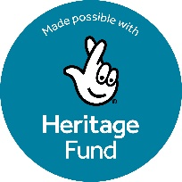
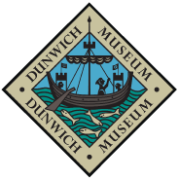
Consultation Feedback
We value your feedback and your engagement with this much-loved community building.
Your answers will help us inform the future of this project, as well as providing us with feedback for the funding bodies. Identifying information will only be shared with the team at the DCHC necessary to process your feedback, after which all data will be anonymised before being shared in any format.
Where do you live? (address or postcode)
What do you think of the plans?
Do the plans cover the needs of the community/museum?
Do you think we have considered the right things going forward?
Do you support the proposals? Why or why not?
Do you have any concerns?
Any other questions, thoughts, or suggestions?

Email us at membership@dunwichmuseum.org.uk to become a member of the DCHC and/or become a volunteer by speaking to Jane or Sarah or by emailing manager@dunwichmuseum.org.uk.

